 **COMPARATIVE ADJECTIVES**

1. **Look at the following images and read the sentences carefully.**

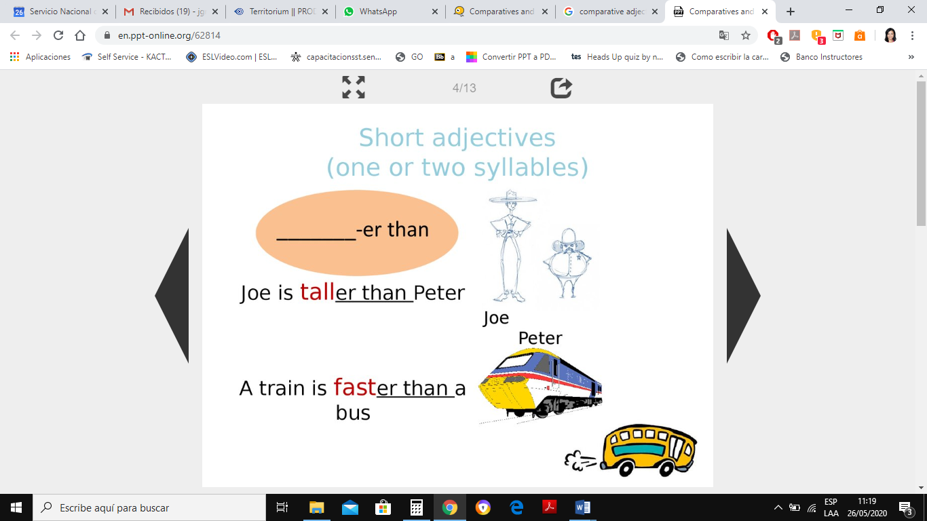

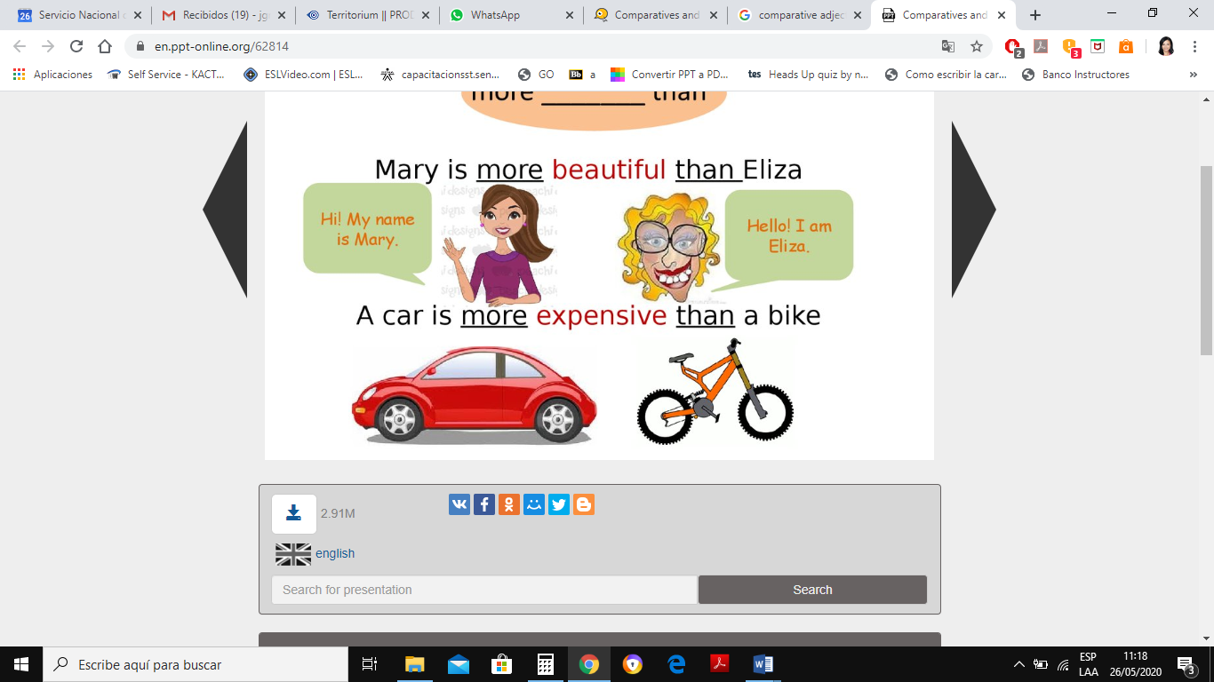

1. **Read the explanation of the Use and Structure of Comparative Adjectives, please take notes.**

**COMPARATIVE ADJECTIVES**

It is used to compare two nouns. Two people , two things, etc.

Examples:

An elephant is **bigger than** a mouse.

Bogotá is **more crowded than** Armenia.

A rabbit is **faster than** a turtle.

**Short Adjectives Long Adjectives**

**Note: than means in Spanish: que (para comparar)**

one or two syllables two or more syllables

Examples: short – shorter Examples: interesting- more interesting

tall – taller expensive- more expensive

hot – hotter boring - more boring

easy – easier handsome- more handsome

**SPELLING RULES FOR SHORT ADJECTIVES:**

1. If the adjective has one or two syllables, add **er**.

long –long**er**  hard- hard**er**  slow – slow**er**

1. If the adjective finishes in e, only add r.

wide –wide**r** large- large**r**  nice- nice**r**

1. If the adjective finishes in consonant + vowel + consonant; double the last consonant and add **er.**

big – big**ger**  thin-thin**ner** fat –fatt**er**

1. If the adjective has two syllables and finishes in Y; it is considered a short adjective so we must change y for i and add er.

pretty – prett**ier** happy – happ**ier** easy -eas**ier**

**SPELLING RULES FOR LONG ADJECTIVES:**

1. If the adjective has two or more syllables, it is considered a long adjective so we must use the word **more**.

dangerous – **more** dangerous beautiful – **more** beautiful difficult –**more** difficult

1. If the adjective has two syllables and it doesn’t finish in Y, it is considered a long adjective so we add more before.

modern– **more** modern honest- **more** honest famous – **more** famous

|  |  |
| --- | --- |
| **IRREGULAR ADJECTIVES** | |
| Good | Better |
| Bad | Worse |
| Far | Farther / Further |

There are some adjectives that are called irregular as we don´t apply to them the spelling rules explained before. These adjectives have their own form.